**DAILY ONLINE ACTIVITIES SUMMARY**

|  |  |  |  |  |  |  |  |  |
| --- | --- | --- | --- | --- | --- | --- | --- | --- |
| **Date:** | 28/05/2020 | | | | | **Name:** | D Richard Franklin | |
| **Sem & Sec** | Fourth SEM section A | | | | | **USN:** | 4AL18CS020 | |
| **Online Test Summary** | | | | | | | | |
| **Subject** | | Microcontroller and Embedded Systems, Aadalitha Kannada | | | | | | |
| **Max. Marks** | | 20, 50 | | **Score** | | | 19, 38 | |
| **Certification Course Summary** | | | | | | | | |
| **Course** | [Certified Kubernetes Administrator (CKA) with Practice Tests](https://www.udemy.com/course/certified-kubernetes-administrator-with-practice-tests/) | | | | | | | |
| **Certificate Provider** | | | Udemy | | **Duration** | | | 3 Hour |
| **Coding Challenges** | | | | | | | | |
| **Problem Statement:** 1. Digital root of a number  2. Counting number of vowels in each substring of a string | | | | | | | | |
| **Status:** Completed | | | | | | | | |
| **Uploaded the report in Github** | | | | | YES | | | |
| **If yes Repository name** | | | | | <https://github.com/richard3658/lockdown-coding> | | | |
| **Uploaded the report in slack** | | | | | YES | | | |

**Online Test Details:**

1. **MES:** The online test was from module 2 which was about the introduction to ARM instruction set and ARM programming using assembly language. There were 20 questions and the duration was 40 minutes. The questions were optimal and were easy. The score that I got in the test is 19/20.
2. **Aadalitha Kannada:** The online test was from all the ten chapters. All were objective type questions and were optimal. There were 50 questions and the duration was 50 minutes. The score that I got is 38/50

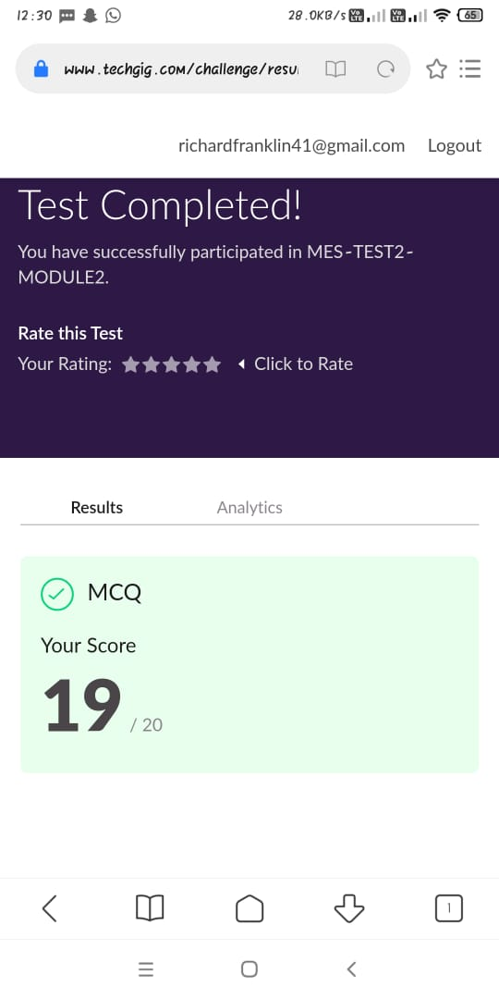 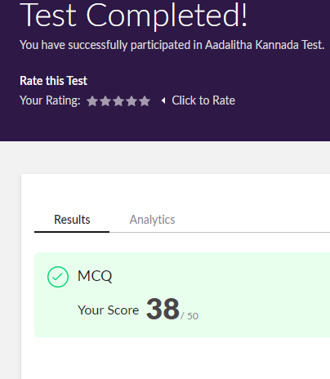

**Certification Course Details:**

**Name of the course**: [Certified Kubernetes Administrator (CKA) with Practice Tests](https://www.udemy.com/course/certified-kubernetes-administrator-with-practice-tests/)

**Certificate Provider**: Udemy

This course has 17 sections and the total duration is 15 hours.

In the tenth day I went through the section of the course that explained about logging & monitoring, application lifecycle management and cluster maintenance. It mainly explained about how Kubernetes can be used optimally.

**Snapshot:**

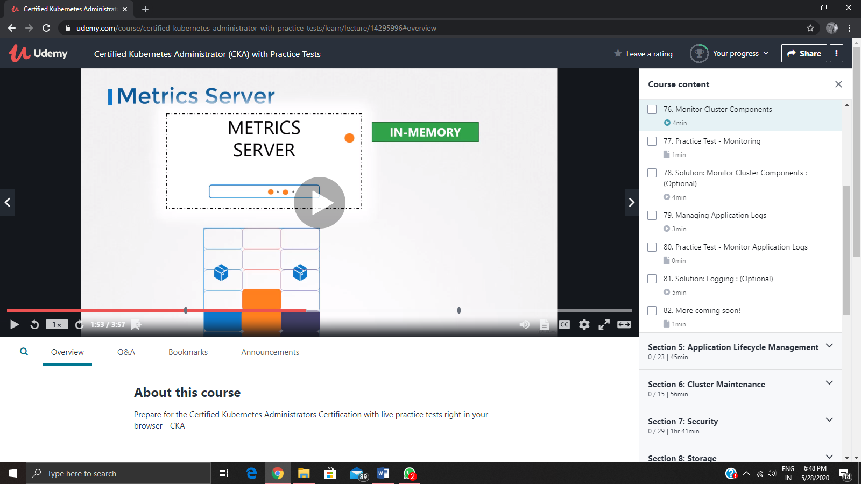

**Online Coding Details:**

Problem 1: (using C language) Write a program to print the digital root of a number.

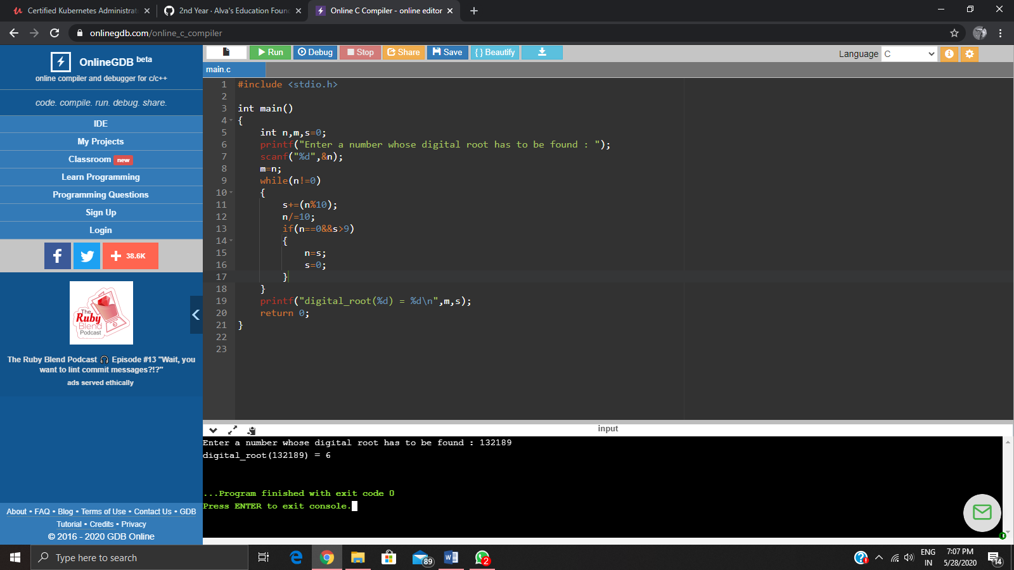

Problem 2: (Using python) Write a program have to find the presence of vowels in all possible substrings of the given string. For each given string you have to print the total number of vowels.

